ELECTRICITY BILL MANAGEMENT SYSTEM

INTRODUCTION

Electricity Bill Management System. This system is made to keep the records about the bills of the customers. The admin can manage all the accounts and the registered users like employees and customers can only manage their own accounts. His system helps in maintaining the bills and the payments. A different module is there for employees to check the customer’s details if their job requires it. Admin, employees, and customers all have a different interface and different privileges according to their needs. Like a customer can only manage his account and cannot see any details of other customers, employees can see the details of all the customer’s accounts and the admin can manage all the accounts including the customers and employees’ accounts. This system also has the option for customers to pay their electricity bills online mode.

ER DAIGRAM: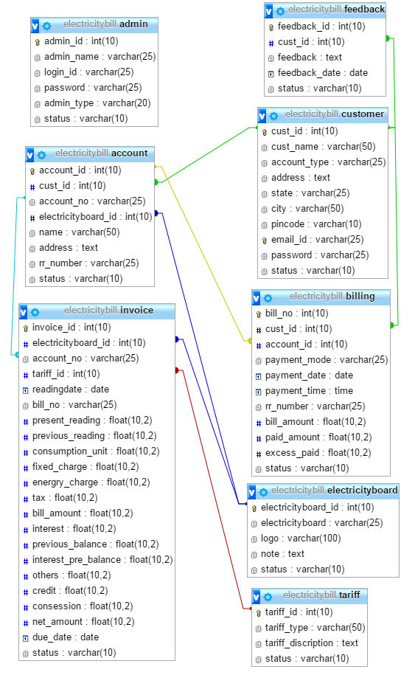

DATABASE DESIGN

Database: electricity_billing_system

TABLES:

1. Account
2. Admin
3. Billing
4. Board
5. Customer
6. Invoice

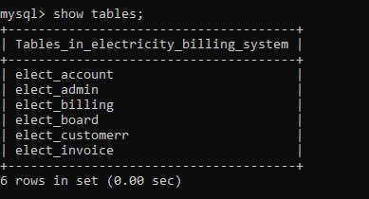

DESCRIBE TABLE:

1. Account: 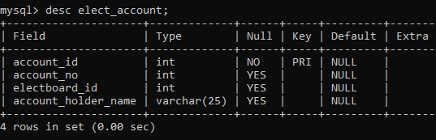
2. Admin: 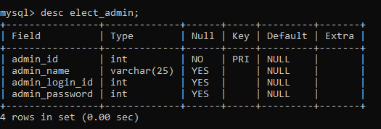
3. Billing:

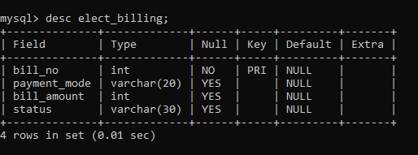

1. Board:

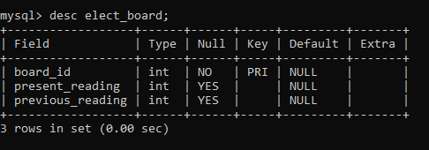

5. Customer:

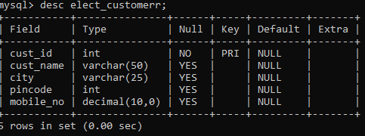

1. Invoice:

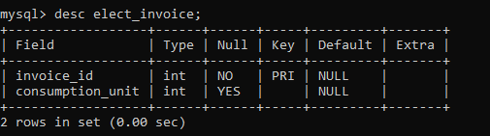

**TABLES: (USING INSERT STATEMENT USING DML COMMANDS)**

1. **Account:**

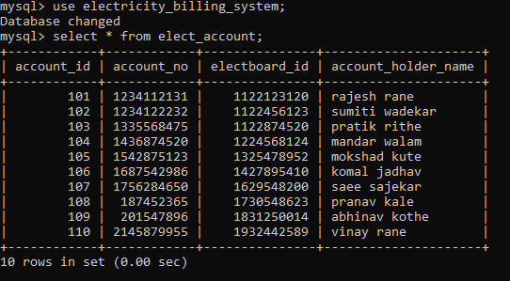

1. **Admin:**

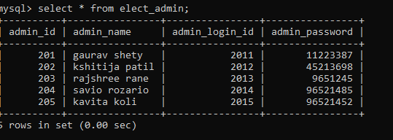

1. **Billing:**

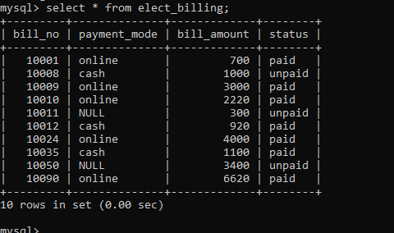

1. **Board:**

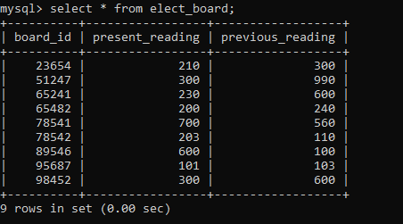

1. **Customer:**

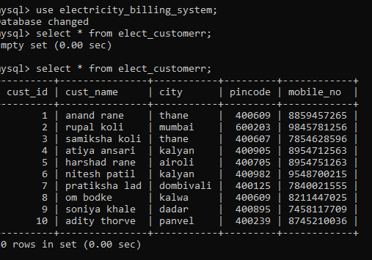

1. **Invoice:**

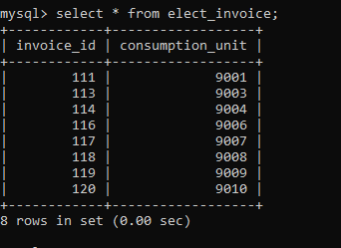

**USING DDL COMMANDS:**

**ALTER:**

**mysql> alter table elect_customerr add column age int;**

**mysql> select * from elect_customerr;**

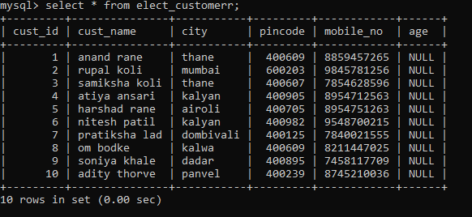

**mysql> alter table elect_billing rename column payment_mode to pay_mode;**

**mysql> select * from elect_billing;**

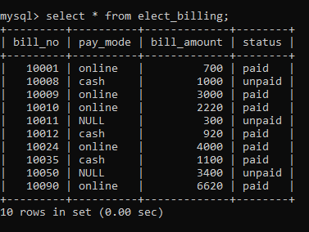

**mysql> alter table elect_admin modify column admin_name varchar(50);**

**mysql> select * from elect_admin;**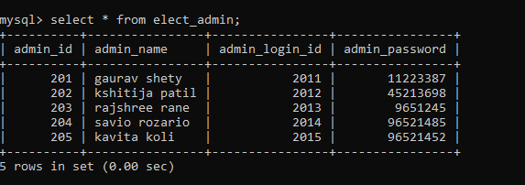

**DROP:**

**alter table elect_account drop column account_holder_name;**

**mysql> select * from elect_account;**

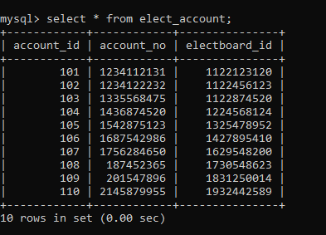

**DML COMMANDS:**

**UPDATE:**

**update elect_customerr set age=25;**

**mysql> select * from elect_customerr;**

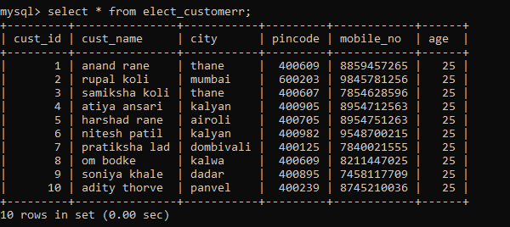

**USING WHERE CLAUSE:**

**update elect_customerr set age=26 where cust_name="anand rane";**

**mysql> select * from elect_customerr;**

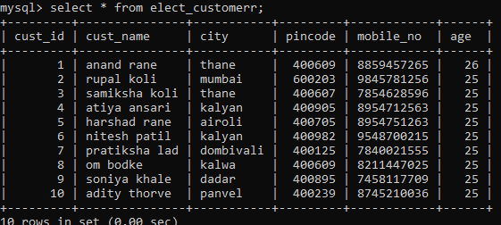

**mysql> update elect_customerr set age=31 where cust_name="pratiksha lad" or cust_id=7;**

**mysql> select * from elect_customerr;**

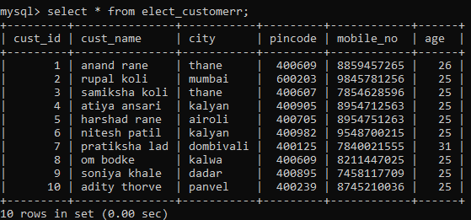

**DELETE STATEMRNT USING WHERE CLAUSE:**

**delete from elect_invoice where invoice_id=120;**

**mysql> select * from elect_invoice;**

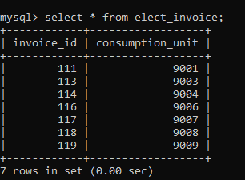

**DQL COMMANDS:**

**SELECT:**

**select * from elect_customerr;**

**select * from elect_customerr limit 5;**

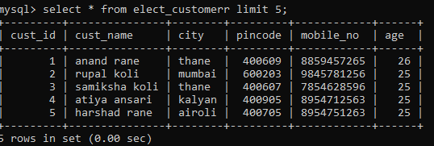

**mysql> select bill_amount from elect_billing where bill_amount>1000;**

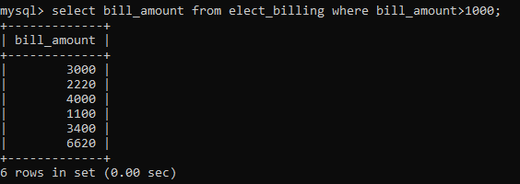

**mysql> select bill_amount,pay_mode from elect_billing where bill_amount<4000 or bill_no=10008;**

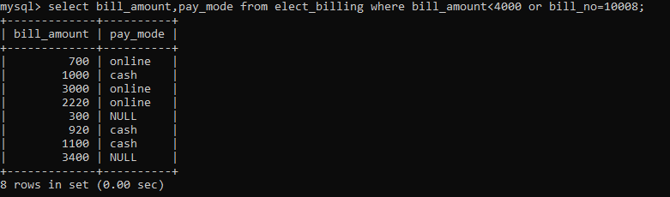

**mysql> select cust_id,city from elect_customerr where cust_id=5 or cust_id=1 or cust_id=10;**

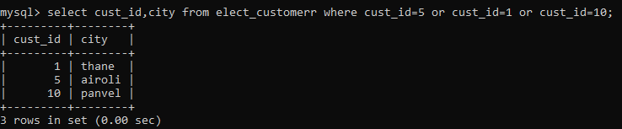

**mysql> select * from elect_board where present_reading between 300 and 600;**

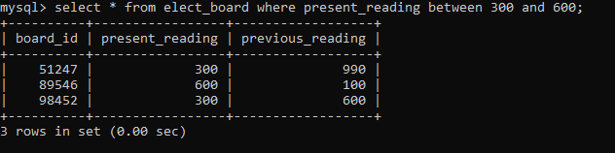

**mysql> select cust_id,pincode from elect_customerr where cust_id in(5,2,9);**

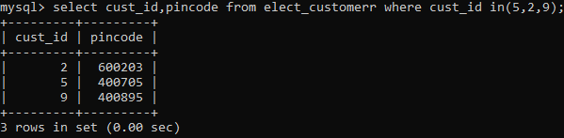

**mysql> select * from elect_board where present_reading not between 100 and 200;**

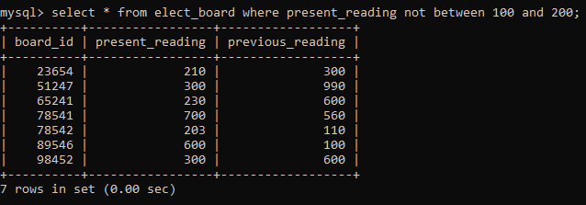

**LIKE OPERATOR:**

**mysql> select * from elect_customerr;**

**mysql> select cust_id,mobile_no,cust_name from elect_customerr where cust_name like'a%';**

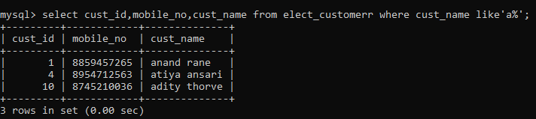

**mysql> select cust_id,mobile_no,cust_name from elect_customerr where cust_name like'a';**

**Empty set (0.00 sec)**

**mysql> select cust_name,mobile_no,city from elect_customerr where cust_name like'_a%';**

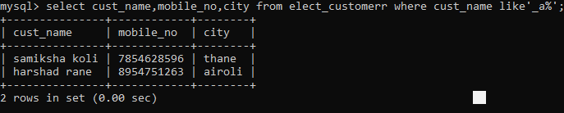

**ORDER BY:**

**mysql> select * from elect_billing;**

**mysql> select * from elect_billing order by bill_amount desc;**

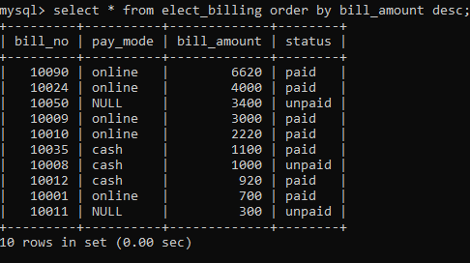

**mysql> select * from elect_billing order by bill_amount asc;**

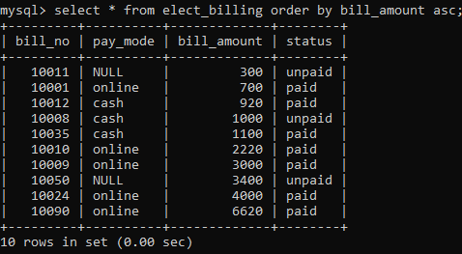

**DISTINCT:**

**mysql> select * from elect_billing;**

**mysql> select distinct bill_amount from elect_billing order by bill_no desc;**

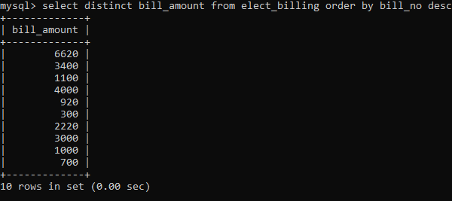

**GROUP BY:**

**mysql> select * from elect_account;**

**mysql> select * from elect_account group by account_id;**

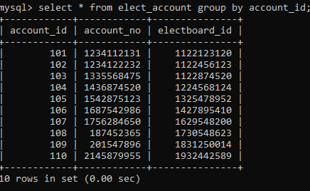

**AGGREGATE FUNCTION:**

**AVERAGE:**

**select * from elect_billing;**

**mysql> select avg(bill_amount) from elect_billing group by bill_no;**

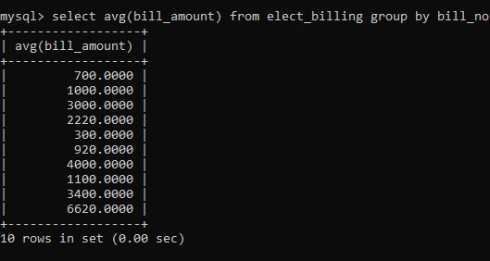

**mysql> select avg(bill_amount),bill_no from elect_billing group by bill_no;**

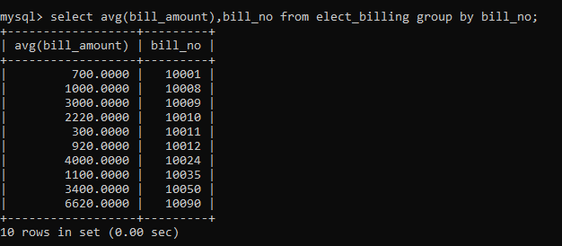

**JOINS**

**LEFT JOIN:**

**mysql> select * from elect_invoice;**

**mysql> select * from elect_board;**

**mysql> select * from elect_invoice left join elect_board on elect_invoice.board_id=elect_board.board_id;**

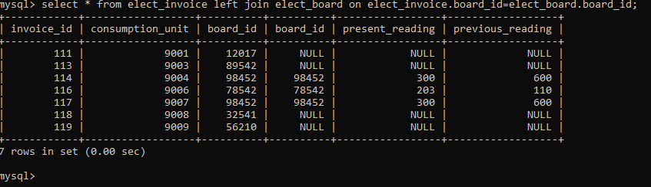

**RIGHT JOIN:**

**mysql> select * from elect_invoice;**

**mysql> select * from elect_board;**

**mysql> select * from elect_invoice right join elect_board on elect_invoice.board_id=elect_board.board_id;**

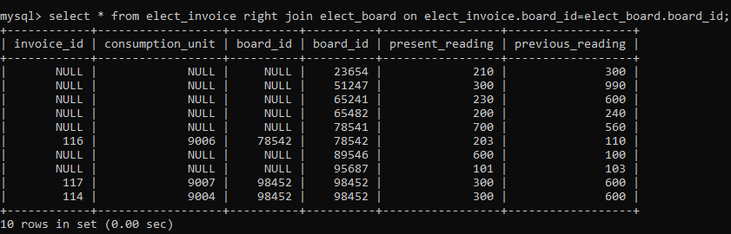

**INNER JOIN:**

**mysql> select * from elect_invoice;**

**mysql> select * from elect_board;**

**mysql> select * from elect_invoice inner join elect_board on elect_invoice.board_id=elect_board.board_id;**

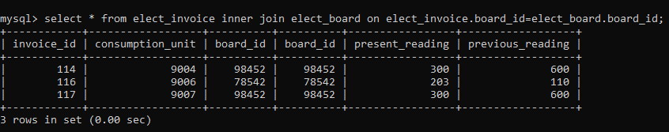

**CROSS JOIN:**

**mysql> select * from elect_invoice;**

**mysql> select * from elect_board;**

**mysql> select * from elect_invoice cross join elect_board;**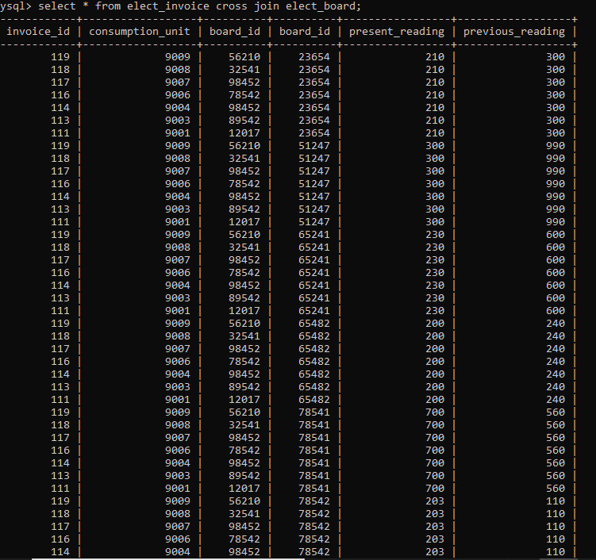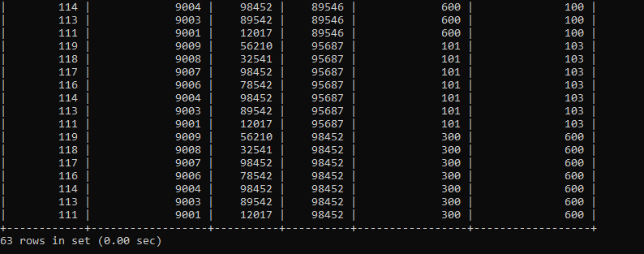

**SELF JOIN:**

**mysql> select * from elect_invoice;**

**mysql> select E1.consumption_unit,E2.consumption_unit from elect_invoice E1 join elect_invoice E2 on E1.invoice_id=E2.board_id;**

**Empty set (0.00 sec)**

**SUBQUERY:**

**mysql> select * from elect_billing;**

**mysql> select bill_no,bill_amount from elect_billing where bill_amount>(select bill_amount from elect_billing where bill_no="10011");**

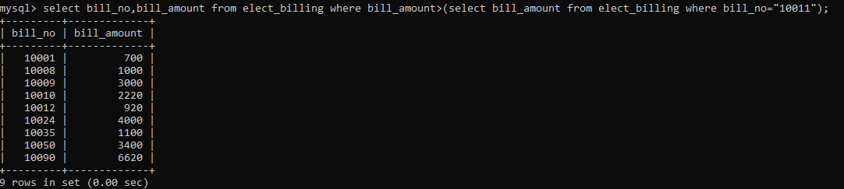

**mysql> select * from elect_billing;**

**mysql> select bill_no,pay_mode,max(bill_amount) from elect_billing where bill_amount<(select max(bill_amount) from elect_billing);**

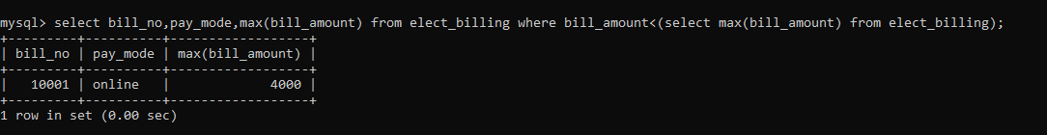

**mysql> select bill_no,pay_mode,max(bill_amount),max(bill_amount) from elect_billing where bill_amount<(select max(bill_amount) from elect_billing);**



**mysql> select bill_no from elect_billing where bill_amount in(select bill_amount from elect_billing where bill_no="10050");**

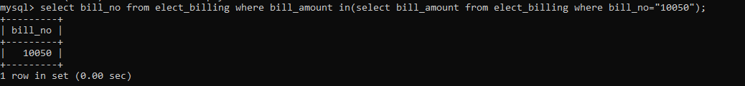

**mysql> select bill_no from elect_billing where bill_amount >any(select bill_amount from elect_billing where bill_no="10050");**

